Al Brando
Contact details  Email  albrandoactor@yahoo.com  Website  www.albrando.net  Phone  07442088529  Education  Diploma In Film Acting  The Film Actors Academy,  London, UK  Instructor: Paul J Lane  Graduated with Distinction 2024  Improv Instruction  The Film Actors Academy,  London  Instructor: Paul J Lane | Agent details  Represented by  The Film Actors Talent Agency  Agent  Paul J Lane  Agent’s phone  07985246311  Agent’s email  info@thefilmactorsacademy.com  Bio  Eye Color: Brown  Height: 5’6”  Hair Color: Black  Weight: 75 Kgs |  | 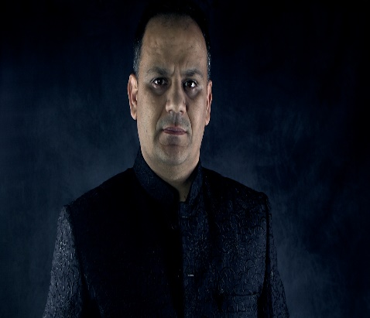
Film & Television Credits
Production |  | Role |  | Director/Production Company
Hello Au Revoir (2021) |  | Actor |  | Jason Croot/JCP Productions
The Terrorists (2017) |  | Actor |  | Paul J Lane/ The Film Actors Club
The Pro (2015) |  | Actor |  | Paul J Lane/Film Coolio Ltd
Special Skills
Fluent in English |  | Can Speak Hindi, Punjabi
Dance |  | Bollywood Style. Western
Accents: British, Asian, Indian, Pakistani
Others: Holds British Passport, Full Driving License

